BESTWOOD VILLAGE WOMENS INSTITUTE

BESTWOOD VILLAGE WI GAZETTE
JANUARY 2022 EDITION

HAPPY NEW YEAR
MY MIND WORKS LIGHT LIGHTNING.
ONE BRILLIANT FLASH AND IT’S GONE
SAME OLD, SAME OLD MESSAGE
We really hope that you find these newsletters interesting and informative. . As always, if you do have any suggestions on how we can improve the content, have anything you would like to share: poems, recipes, gardening tips, crafts etc. please send them to either Janet or Jan who will do their best to include them.

DECEMBER SOCIAL MEETING
Thanks to everyone for attending and making our Christmas Social an enjoyable evening, hopefully everyone had a nice time and were pleased with their raffle prizes and gifts.

JANUARY MEETING
*26th January 2002 at Welfare Pub + Kitchen 7.00pm
*On this day in 1945 the Nazi concentration camp Auschwitz, Poland was liberated by Soviet troops and in 1988 Andrew Lloyd Webber’s ‘The Phantom of the Opera’ opened in New York.
Also, in 1925 Paul Newman was born.

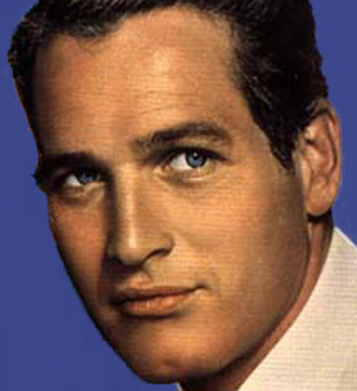

Our programme says that January will be a Social Evening but Elizabeth has managed to book a speaker who is going to talk to us about ‘Health and Nutrition’ to, hopefully, help us all to keep to our New Year’s Resolutions.

GUESS WHO HAS A BRITHDAY NEXT MONTH AND BECAUSE WE WERE ALL BUSY GETTING READY FOR SANTA WE ARE INCLUDING JANUARY’S BIRTHDAYS IN THIS NEWSLETTER
This Photo by Unknown Author is licensed under CC BY-NC
Marguerite Hodkinson 4th January
Angela Ingers 15th January
Doreen Hooi 20th January
Maureen Standen 21st January
Diana Montgomery 22nd February

CRAFT WORKSHOP
Our craft workshop on 22nd November at the Dynamo Café was a wreath making lesson by Janet and everyone was happy with the results.

Our next workshop is scheduled for the 17th January which will be a Coffee/Social morning.

2022/23 PROGRAMME
The programme has now been set and some of our demonstrators and guests have been booked. A full printed programme will be available at the February Annual Meeting.

DON’T FORGET

That in February, at our Annual Meeting, we will be asking for nominations for Committee Members and subsequently electing a President 2022/23. More of this at our January meeting.

Also on a positive note we no longer have to pay our subscriptions in February we can save our pennies until April.

BESTWOOD VILLAGE WI ON TOUR
A mini bus took 16 members and guests to Bakewell Christmas Market on 20th November 2021 although the market was extremely busy the outing was a great success.
WI MEETING
If possible, could you please donate prizes for the raffles, this is a stand-alone fund raiser and not associated with the WI in any way. The money raised it used for our Christmas Social Evening and other events that the WI Constitution forbids us to pay for out of WI funds. A full and accurate records of all income and expenditure is available if anyone would like to look at it.
CHRISTMAS FAYRE
The Christmas Fayre held on the 5th December at the Welfare Pub + Kitchen was a fantastic triumph. Thanks to all the members who turned up on the day to help, Sandra, Doreen, Judy, Jackie, Marion it really was appreciated.

DID YOU KNOW?

There is more vitamin C in one Kiwi than 10 oranges also Sweet Potatoes count as one of your five a day but normal potations don’t nor does Carrot Cake.
Please remember to let Jan know if there are any changes in your contact details

Please feel free to share this newsletter with family and friends to encourage them to join us.
CONTACT DETAILS
Elizabeth Heard, President Tel: 0115 9750787
Janet Wheat, Vice President Tel: 07758 862990
Jan Pauley, Treasurer & Secretary Tel: 07944 214028

